Taxpayers must make estimated tax payments if they expect to owe at least $1,000 in tax (after subtracting withholding and credits) and their withholding and credits will be less than the smaller of:
• 90% of the tax shown on the current tax return or
• 100% of the tax shown on the prior year’s tax return (110% for certain higher-income taxpayers; see Form 1040-ES)
An estimated tax penalty may apply if the taxpayer does not make estimated tax payments as required. There are special situations when a taxpayer will not have to pay a penalty. Form 2210 is used to calculate estimated tax penalties. Volunteer preparers are not to calculate estimated tax penalties.

Penalties for underpayment of taxes
- Federal – when the amount owed is over $1,000 a message will appear when e-file is begun stating:
The balance due on your Federal return is more than $1000. You may be subject to an estimated tax penalty. If there is a penalty due, the IRS will calculate the penalty and send a notice by mail.
If you would like to complete Form 2210 go to Federal Section >> Payments & Estimates >> Underpayment of Estimated Tax.
  - Alert the taxpayer that they may be subject to a penalty and why
  - Advise the taxpayer on how to prevent this situation in the future
  - No action in TaxSlayer is required
- New Jersey - There is no message in the efile for the NJ return, but the penalty does not seem to be carrying to the NJ 1040.
- Check that there is no amount in the Federal 1040 Line 23 and the NJ 1040 Line 51.

If Penalties do appear in the Federal 1040 Line 23 or the NJ 1040 Line 51, follow the process below to remove the penalty

Federal Form 2210
- In TaxSlayer to remove 1040, line 23 Estimated tax penalty: Federal Section > Payments &
Estimates > Underpayment of Estimated Tax

Step - 1 - Enter the prior year’s tax in the first box. Look at the 1040 line 23. If the penalty is gone, you
are done
Step - 2 - Enter the payment date (the date you will be paying your 2018 balance to the IRS)
Step –3 – Request a waver and use the reason “To be calculated by IRS"

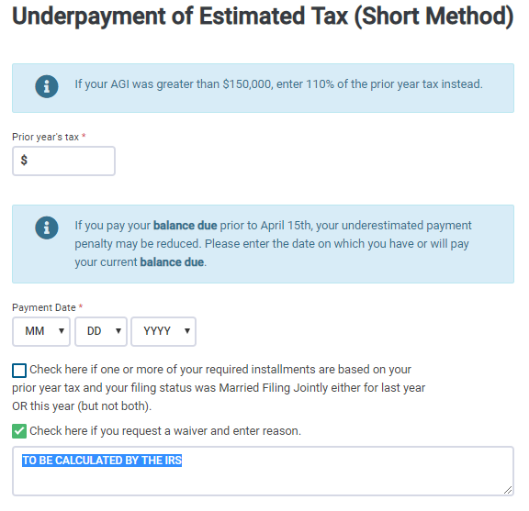
Step -3
Step -2
Step -1

NJ Form 2210
- In TaxSlayer to remove line 51 (Penalty for Underpayment of Estimated Tax) New Jersey Return > Miscellaneous Forms > Form NJ-2210 Underpayment of Estimated Tax. Answer No to the question “To complete NJ 2210 Underpayment of Estimated Tax select YES and complete the information below.

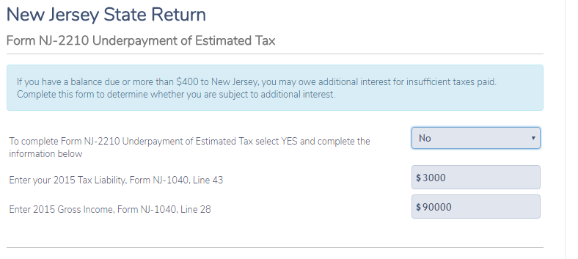

The only way to determine if there may be a penalty is to look at the Federal 1040 line 23 and/or NJ 1040 line 51.

